7-3 Project Two:

Software Design Document

CHRISTOPHER DAVIDSON | CS-255 System Analysis and Design | 10/20/24

# CS 255 System Design Document Template

This template lays out all the different sections that you need to complete for Project Two. Each section has guidance to prompt your thinking. You will need to continually reference the interview transcript as you work to make sure that you are addressing your client’s needs. There is no required length for the final document. Instead the goal is to complete each section based on what your client’s needs are. Remove this note when you are finished, and replace all bracketed text with the relevant information.

## UML Diagrams

### UML Use Case Diagram

### UML Activity Diagrams

### UML Sequence Diagram

### UML Class Diagram

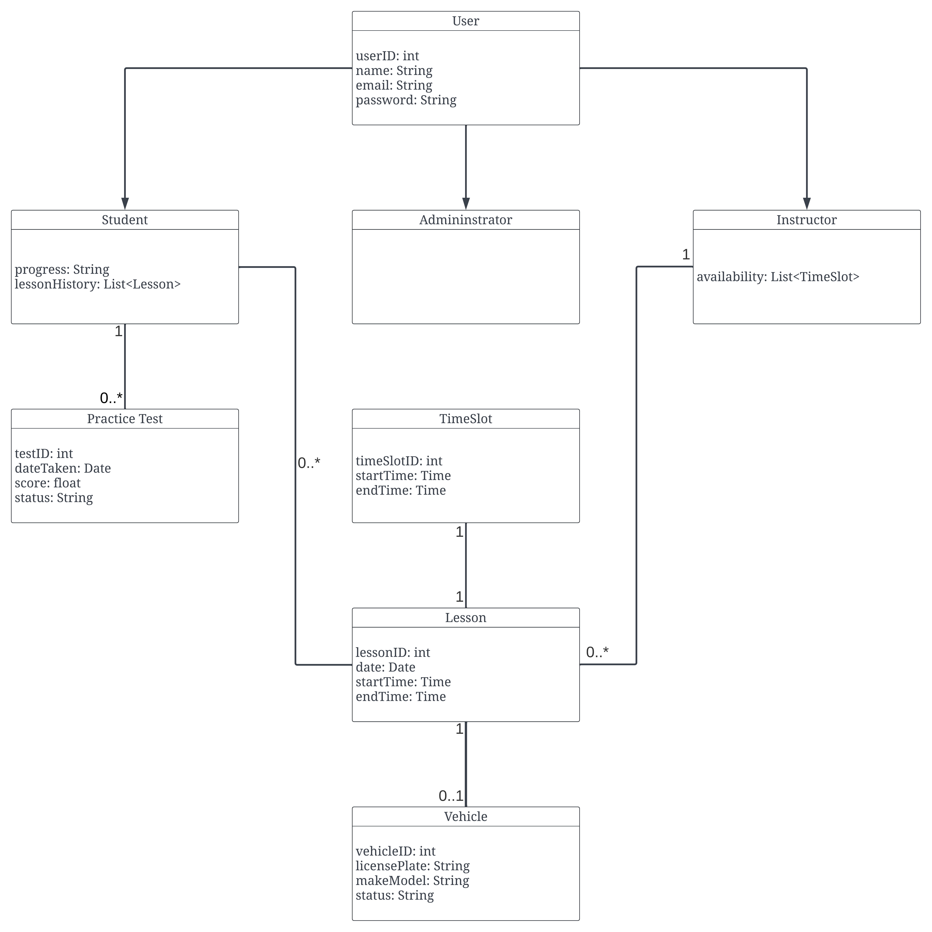

## Technical Requirements

The DriverPass system requires several key technical components to ensure it functions effectively and meets user needs. Below is a detailed breakdown of hardware, software, tools, and infrastructure requirements based on the business requirements.

**1. Hardware Requirements:**

* **Servers**:
  + Scalable cloud-hosted servers will be used to accommodate fluctuations in user traffic. During peak DMV testing periods, the system should handle up to 500 users with automatic scaling and redundancy to ensure uptime and prevent data loss​​.
* **Client Devices**:
  + Users (students, instructors, and administrators) will access the system through a wide range of devices including desktops, laptops, tablets, and smartphones. Offline functionality is available for instructors, allowing them to input lesson feedback and sync data once internet access is restored​.
* **Storage**:
  + Ample storage is required to securely maintain user data (lesson schedules, progress reports, test results). Backup and redundancy mechanisms will be integrated, with daily encrypted backups stored across geographically diverse locations​​.

**2. Software Requirements:**

* **Operating Systems**:
  + The system will be compatible with all major operating systems, including Windows, macOS, Linux, iOS, and Android. Server-side operating systems will process requests and handle data while client-side systems will interact with the web-based platform​.
* **Web Application**:
  + A modern web framework will provide a responsive user interface that students can access from any device, allowing for real-time scheduling, lesson management, and progress tracking​.
* **Database Management**:
  + The system will use a cloud-based, scalable database management system (DBMS) capable of handling user profiles, lesson data, test scores, and administrative records efficiently​​.

**3. Security and Compliance:**

* **Encryption and Secure Data Transmission**:
  + SSL/TLS encryption will protect sensitive data during transmission, ensuring that user credentials and payment details remain secure​.
* **Role-Based Access Control (RBAC)**:
  + The system will implement RBAC, where students, instructors, and administrators will have different permissions. Administrators will have full system access, instructors will manage lessons and feedback, and students will schedule lessons and monitor progress​.
* **Multi-Factor Authentication (MFA)**:
  + For critical users like administrators, MFA will be required to log in, adding an extra layer of protection against unauthorized access​.
* **Audit Logs**:
  + The system will maintain detailed audit logs that track changes made by users (e.g., booking, cancellation, or rescheduling of lessons) to ensure transparency and accountability​.

**4. Infrastructure Requirements:**

* **Cloud Infrastructure**:
  + The system will be hosted on a cloud-based platform to ensure flexibility, scalability, and high availability. This infrastructure will support automatic scaling during high demand periods, ensuring reliable access to students and instructors​.
* **Backup and Redundancy**:
  + Regular encrypted backups will be performed to prevent data loss in case of system failure. A recovery plan will ensure that the system remains available with minimal downtime​​.

**5. Tools and Testing:**

* **Development Tools**:
  + Developers will use IDEs like **Visual Studio** and version control systems like **GitHub** to manage the system development process and ensure smooth collaboration​.
* **Testing Tools**:
  + Both **automated** and **manual testing tools** will be used, including **JUnit** for unit testing, **Selenium** for UI testing, and **Apache JMeter** for load testing to ensure the system handles peak traffic​.